SERVICE NOW PROJECT REPORT
ServiceNow Operations Ticket Management System

1. INTRODUCTION
1.1 Project Overview
The ServiceNow Operations Ticket Management System is designed to automate the process of managing operational support requests within an organization. The system enables users to raise issues related to platform access, certification services, and operational problems while automatically routing tickets to appropriate support teams using workflow automation.

1.2 Purpose
The purpose of this project is to:
- Reduce manual ticket assignment
- Improve operational efficiency
- Automate issue routing
- Enhance user satisfaction
- Enable faster issue resolution

2. IDEATION PHASE
2.1 Problem Statement
Organizations face delays in resolving operational issues due to manual ticket handling and improper workload distribution. Lack of automation results in slower response time and reduced productivity.

2.2 Empathy Map Canvas
The empathy analysis identified user frustrations such as delayed ticket resolution, manual communication, and inefficient support processes. Users require automated systems that ensure faster and accurate ticket handling.
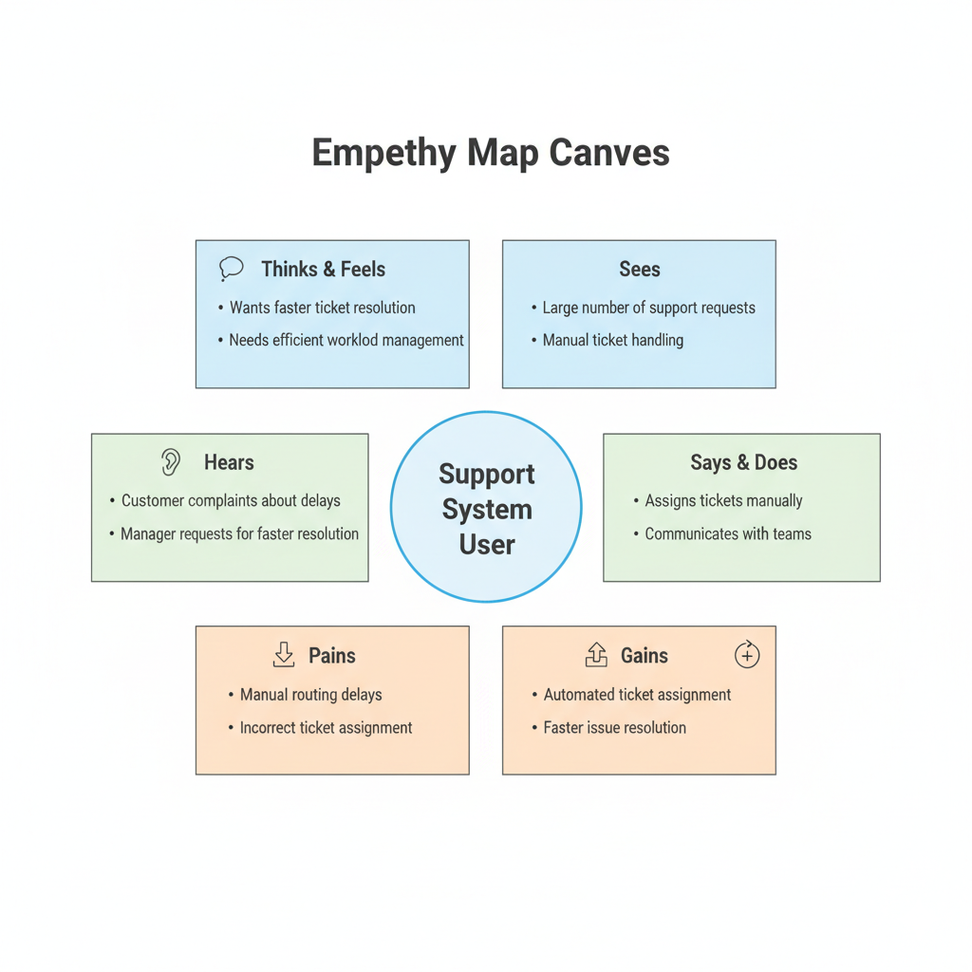
2.3 Brainstorming
Brainstorming sessions explored solutions such as automated ticket routing, role-based access management, and workflow automation using ServiceNow Flow Designer.

3. REQUIREMENT ANALYSIS
3.1 Customer Journey Map
The customer journey includes issue identification, ticket submission, automated routing, support resolution, and user notification.
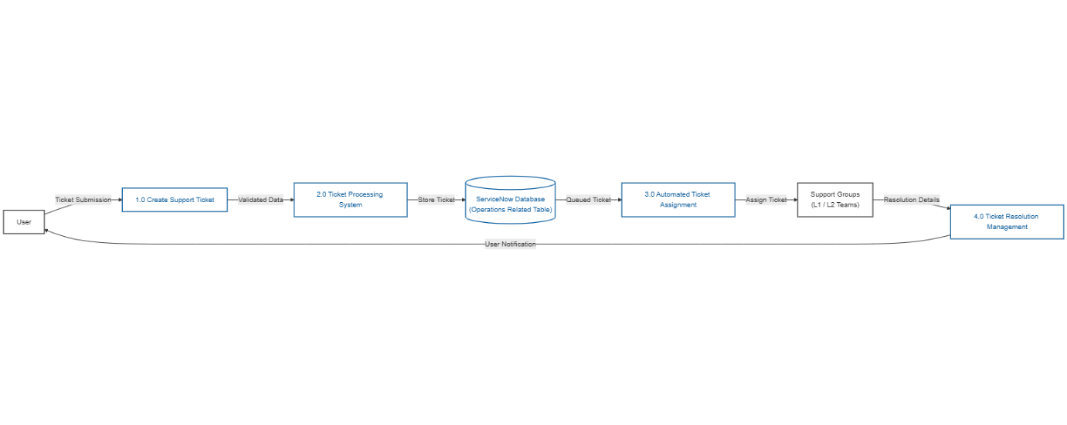

3.2 Solution Requirement
Functional Requirements
- Ticket creation module
- Issue categorization
- Automated assignment
- Role-based access
- Ticket tracking
Non-Functional Requirements
- System reliability
- Fast response time
- Secure access control
- High availability

3.3 Data Flow Diagram
The system processes ticket requests from users and routes them through automated workflows to support teams.
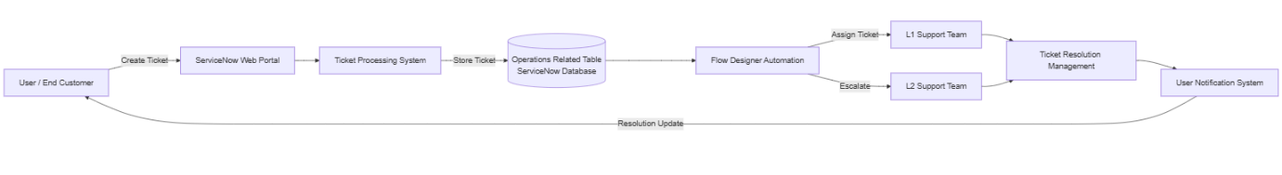

3.4 Technology Stack
Component | Technology
Platform | ServiceNow
Workflow Automation | Flow Designer
Database | ServiceNow Tables
Security | ACL & Roles
Interface | ServiceNow Forms
Deployment | Cloud Platform

4. PROJECT DESIGN
4.1 Problem Solution Fit
The proposed solution aligns with user needs by automating ticket routing and minimizing manual workload.
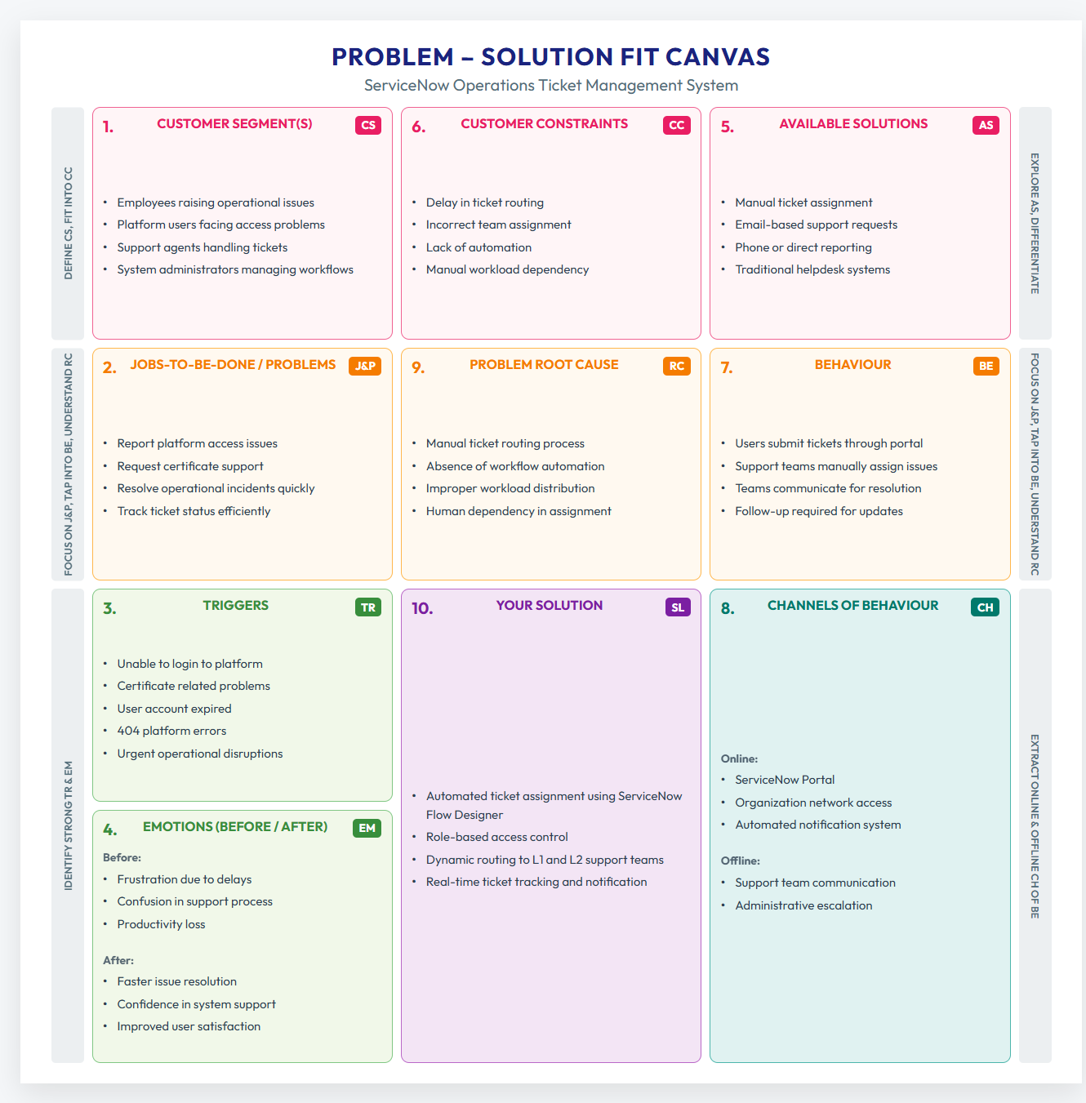

4.2 Proposed Solution
The system automatically assigns operational tickets to L1 or L2 support teams based on issue type using predefined workflows.

4.3 Solution Architecture
The architecture consists of user interface forms, ServiceNow database tables, workflow automation, and support group management.
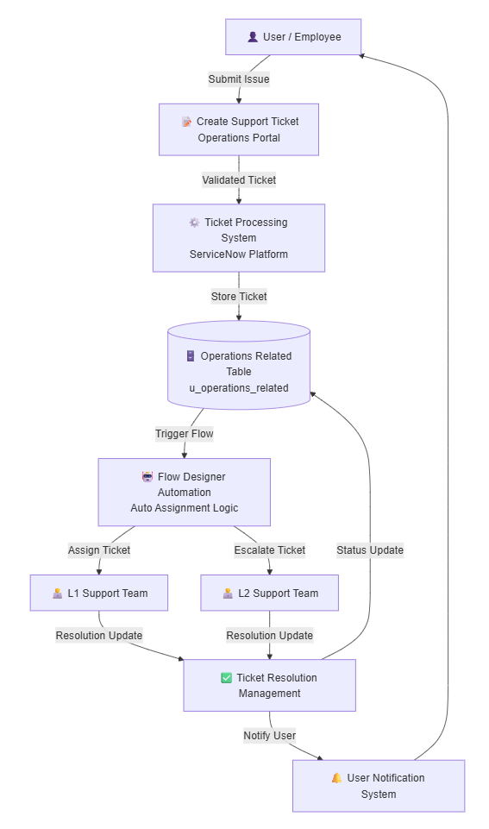
5. PROJECT PLANNING & SCHEDULING
5.1 Project Planning
The project was executed using Agile methodology with sprint-based planning involving requirement analysis, development, testing, and deployment phases.

6. FUNCTIONAL AND PERFORMANCE TESTING
6.1 Performance Testing
Performance testing validated system responsiveness and workflow execution efficiency.
Test Environment
Parameter | Details
Platform | ServiceNow Developer Instance
Application | Operations Related Module
Users Tested | Admin, Support Agent
Database | ServiceNow Table
Browser | Google Chrome

Performance Test Scenarios
Test Case ID | Scenario | Expected Result | Actual Result | Status
PT01 | Create Operations Ticket | Ticket created instantly | Successful | Pass
PT02 | Flow Trigger Execution | Auto assignment triggered | Successful | Pass
PT03 | Database Storage | Record stored correctly | Successful | Pass
PT04 | Group Assignment | Ticket assigned automatically | Successful | Pass
PT05 | Multiple Ticket Creation | System stable | Successful | Pass

Performance Metrics
Metric | Result
Ticket Creation Time | < 2 seconds
Flow Execution Time | < 3 seconds
Response Time | Fast
System Stability | Stable
Automation Accuracy | 100%

7. RESULTS
7.1 Output Screenshots
- User Creation
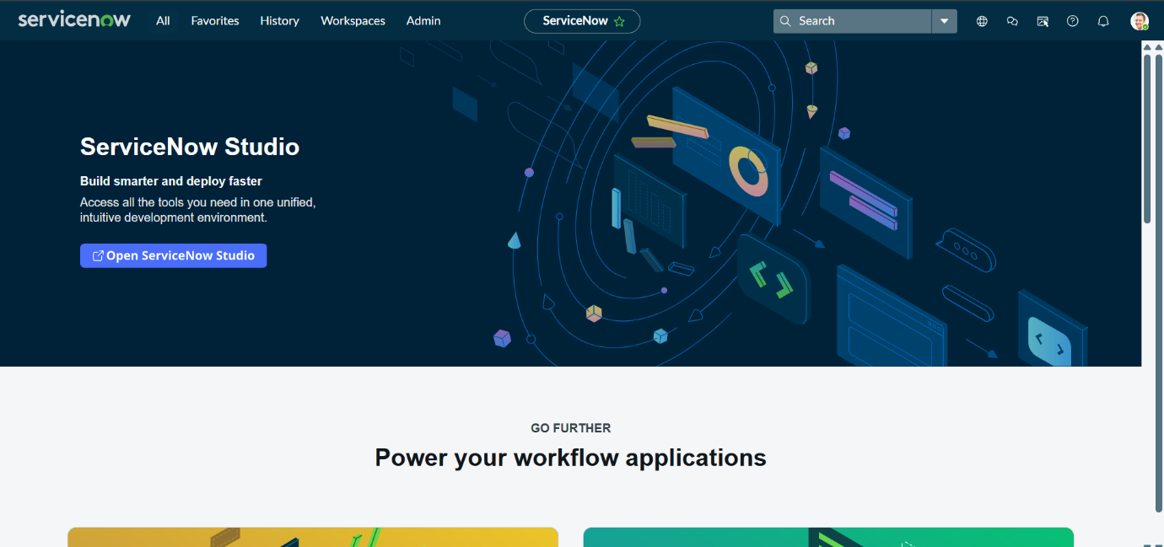
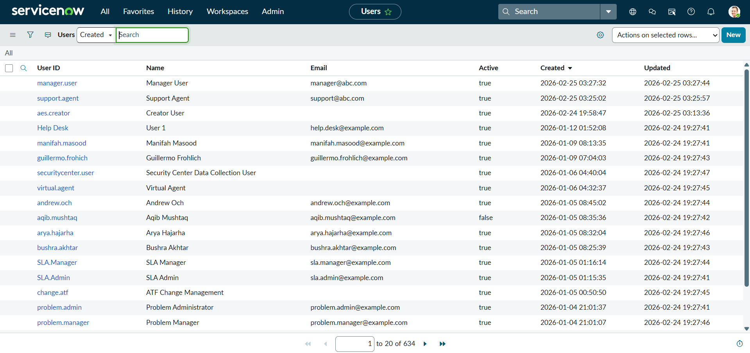
- Group Configuration
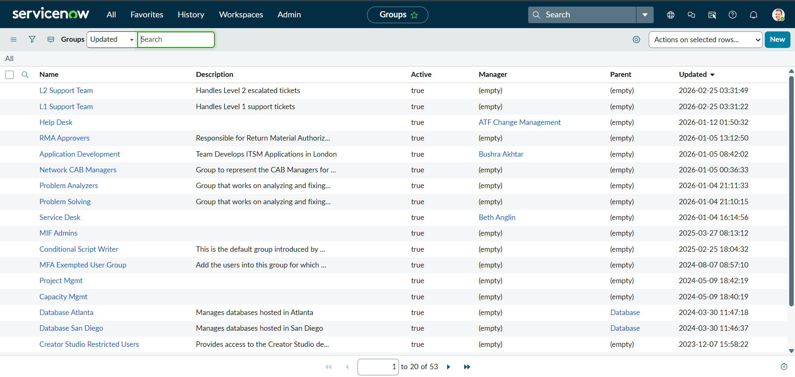
- Table Creation
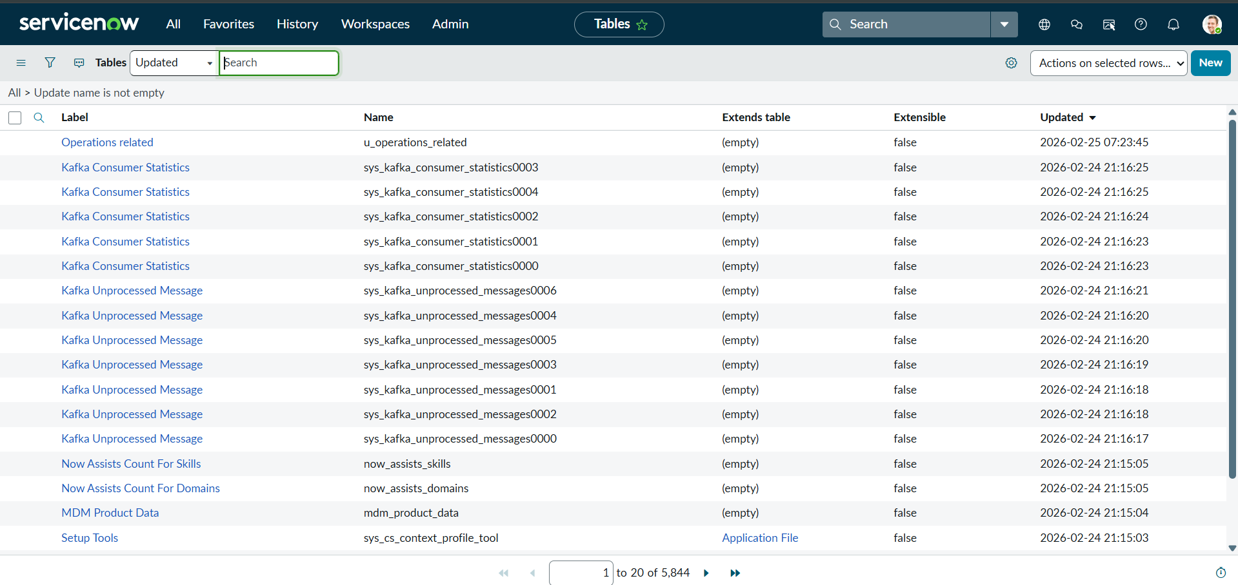
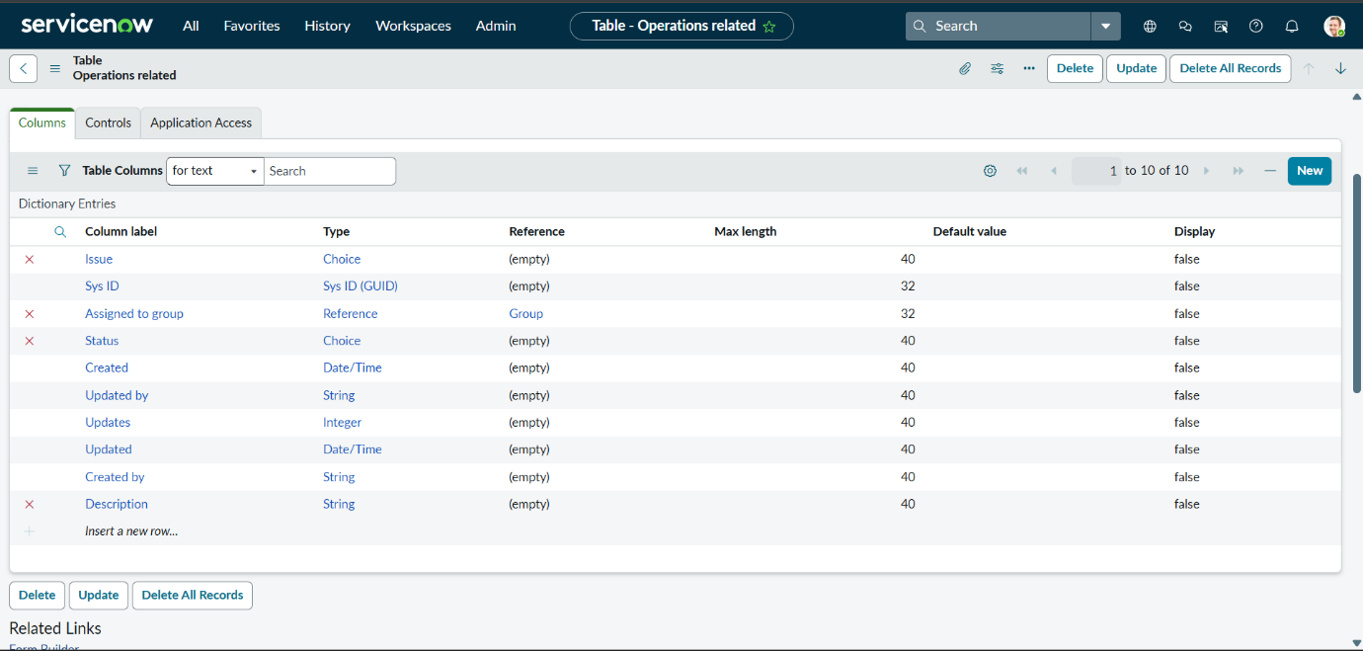
- ACL Configuration
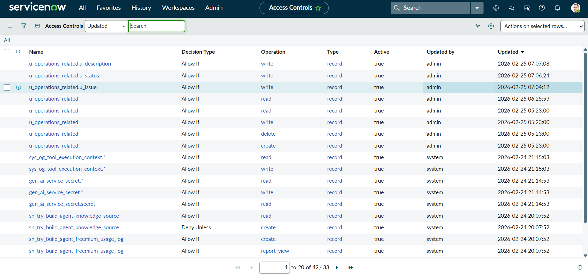
- Flow Automation
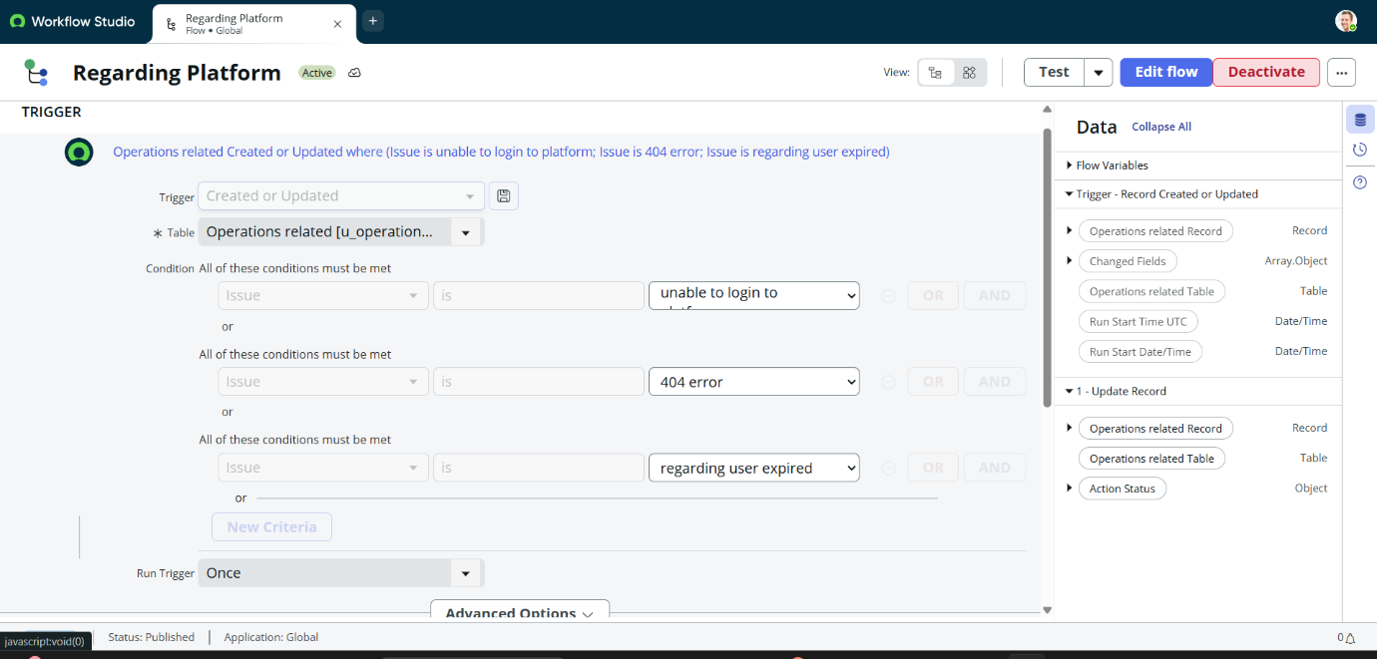
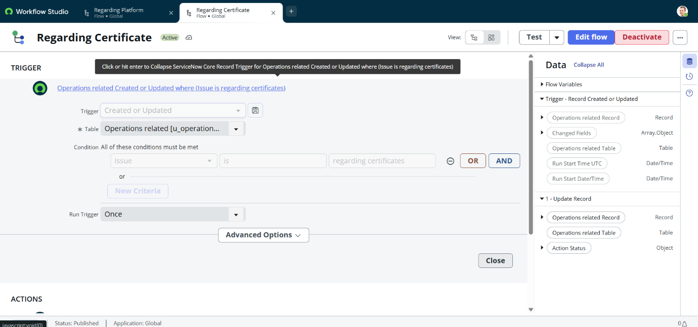
- Ticket Assignment Results
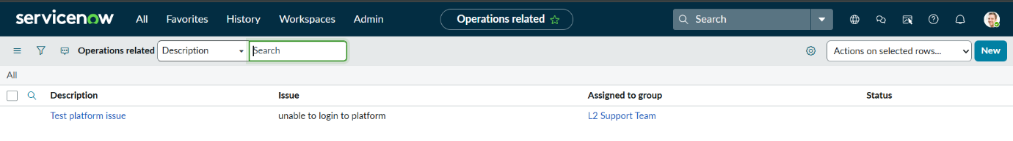
8. ADVANTAGES & DISADVANTAGES
Advantages
- Automated ticket routing
- Reduced manual effort
- Faster issue resolution
- Improved operational efficiency
Disadvantages
- Requires ServiceNow platform access
- Initial configuration complexity

9. CONCLUSION
The ServiceNow Operations Ticket Management System successfully automates operational issue handling and improves support efficiency through workflow automation and role-based access control.

10. FUTURE SCOPE
- AI-based ticket prioritization
- Chatbot integration
- Predictive issue analytics
- Mobile support dashboard

11. APPENDIX
Source Code
ServiceNow configuration scripts and workflows
GitHub & Project Demo Link
- GitHub Repository: https://github.com/Narasimha-kambham/ServiceNow-Operations-Ticket-Management-System.git
- Demo Video Link: https://drive.google.com/file/d/1iW-9wNSv7SRmrtnfKlPyXA6vdG8Lzgiq/view?usp=sharing

